

**General Sir John Kotelawala Defense University**

**Faculty of Computing**

BSC DEGREE IN COMPUTER SCIENCE/ COMPUTER ENGINEERING/ SOFTWARE ENGINEERING

**Image Processing and Computer Vision – CS3042**

**INTAKE 36**

ASSIGNMENT – 03

AMRNVB Pethiyagoda

D/BCE/19/0002

Suggest an algorithm using image processing techniques and develop a MAT LAB code For

**“Vehicle Number Plate Detection and Recognition”.**

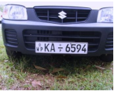

Include following sections to your report

1. System Architecture
2. Activity Diagram (Process flow chart)
3. Image Processing Techniques

**MAT LAB Code**

**Below code is for create_templates.m file**

A=imread('A.bmp');

B=imread('B.bmp');

C=imread('C.bmp');

D=imread('D.bmp');

E=imread('E.bmp');

F=imread('F.bmp');

G=imread('G.bmp');

H=imread('H.bmp');

I=imread('I.bmp');

J=imread('J.bmp');

K=imread('K.bmp');

L=imread('L.bmp');

M=imread('M.bmp');

N=imread('N.bmp');

O=imread('O.bmp');

P=imread('P.bmp');

Q=imread('Q.bmp');

R=imread('R.bmp');

S=imread('S.bmp');

T=imread('T.bmp');

U=imread('U.bmp');

V=imread('V.bmp');

W=imread('W.bmp');

X=imread('X.bmp');

Y=imread('Y.bmp');

Z=imread('Z.bmp');

Afill=imread('fillA.bmp');

Bfill=imread('fillB.bmp');

Dfill=imread('fillD.bmp');

Ofill=imread('fillO.bmp');

Pfill=imread('fillP.bmp');

Qfill=imread('fillQ.bmp');

Rfill=imread('fillR.bmp');

one=imread('1.bmp');

two=imread('2.bmp');

three=imread('3.bmp');

four=imread('4.bmp');

five=imread('5.bmp');

six=imread('6.bmp');

seven=imread('7.bmp');

eight=imread('8.bmp');

nine=imread('9.bmp');

zero=imread('0.bmp');

zerofill=imread('fill0.bmp');

fourfill=imread('fill4.bmp');

sixfill=imread('fill6.bmp');

sixfill2=imread('fill6_2.bmp');

eightfill=imread('fill8.bmp');

ninefill=imread('fill9.bmp');

ninefill2=imread('fill9_2.bmp');

letter=[A Afill B Bfill C D Dfill E F G H I J K L M...

N O Ofill P Pfill Q Qfill R Rfill S T U V W X Y Z];

number=[one two three four fourfill five...

six sixfill sixfill2 seven eight eightfill nine ninefill ninefill2 zero zerofill];

character=[letter number];

NewTemplates=mat2cell(character,42,[24 24 24 24 24 24 24 24 ...

24 24 24 24 24 24 24 ...

24 24 24 24 24 24 24 ...

24 24 24 24 24 24 24 ...

24 24 24 24 24 24 24 ...

24 24 24 24 24 24 24 ...

24 24 24 24 24 24 24]);

save ('NewTemplates','NewTemplates')

clear all

**Below code is for App.m file (Vehicle Number Plate Detection and Recognition GUI)**

function varargout = App(varargin)

% APP MATLAB code for App.fig

% APP, by itself, creates a new APP or raises the existing

% singleton*.

%

% H = APP returns the handle to a new APP or the handle to

% the existing singleton*.

%

% APP('CALLBACK',hObject,eventData,handles,...) calls the local

% function named CALLBACK in APP.M with the given input arguments.

%

% APP('Property','Value',...) creates a new APP or raises the

% existing singleton*. Starting from the left, property value pairs are

% applied to the GUI before App_OpeningFcn gets called. An

% unrecognized property name or invalid value makes property application

% stop. All inputs are passed to App_OpeningFcn via varargin.

%

% *See GUI Options on GUIDE's Tools menu. Choose "GUI allows only one

% instance to run (singleton)".

%

% See also: GUIDE, GUIDATA, GUIHANDLES

% Edit the above text to modify the response to help App

% Last Modified by GUIDE v2.5 11-Jun-2021 19:22:52

% Begin initialization code - DO NOT EDIT

gui_Singleton = 1;

gui_State = struct('gui_Name', mfilename, ...

'gui_Singleton', gui_Singleton, ...

'gui_OpeningFcn', @App_OpeningFcn, ...

'gui_OutputFcn', @App_OutputFcn, ...

'gui_LayoutFcn', [] , ...

'gui_Callback', []);

if nargin && ischar(varargin{1})

gui_State.gui_Callback = str2func(varargin{1});

end

if nargout

[varargout{1:nargout}] = gui_mainfcn(gui_State, varargin{:});

else

gui_mainfcn(gui_State, varargin{:});

end

% End initialization code - DO NOT EDIT

% --- Executes just before App is made visible.

function App_OpeningFcn(hObject, eventdata, handles, varargin)

% This function has no output args, see OutputFcn.

% hObject handle to figure

% eventdata reserved - to be defined in a future version of MATLAB

% handles structure with handles and user data (see GUIDATA)

% varargin command line arguments to App (see VARARGIN)

set(handles.OriginalImage,'visible', 'off');

% Choose default command line output for App

handles.output = hObject;

% Update handles structure

guidata(hObject, handles);

% UIWAIT makes App wait for user response (see UIRESUME)

% uiwait(handles.figure1);

% --- Outputs from this function are returned to the command line.

function varargout = App_OutputFcn(hObject, eventdata, handles)

% varargout cell array for returning output args (see VARARGOUT);

% hObject handle to figure

% eventdata reserved - to be defined in a future version of MATLAB

% handles structure with handles and user data (see GUIDATA)

% Get default command line output from handles structure

varargout{1} = handles.output;

% --- Executes on button press in pushbutton1.

function pushbutton1_Callback(hObject, eventdata, handles)

% hObject handle to pushbutton1 (see GCBO)

% eventdata reserved - to be defined in a future version of MATLAB

% handles structure with handles and user data (see GUIDATA)

[Filename,Pathname]=uigetfile('*.jpg','Select Image');

fullpath=strcat(Pathname,Filename);

f=imread(fullpath);

axes(handles.OriginalImage);

imshow(f);

f=imresize(f,[400 NaN]);

g=rgb2gray(f);

g=medfilt2(g,[3 3]);

se=strel('disk',1);

gi=imdilate(g,se);

ge=imerode(g,se);

gdiff=imsubtract(gi,ge);

gdiff=mat2gray(gdiff);

gdiff=conv2(gdiff,[1 1;1 1]);

gdiff=imadjust(gdiff,[0.5 0.7],[0 1],0.1);

B=logical(gdiff);

er=imerode(B,strel('line',50,0));

out1=imsubtract(B,er);

F=imfill(out1,'holes');

H=bwmorph(F,'thin',1);

H=imerode(H,strel('line',3,90));

final=bwareaopen(H,100);

Iprops=regionprops(final,'BoundingBox','Image');

NR=cat(1,Iprops.BoundingBox);

r=controlling(NR);

if ~isempty(r)

I={Iprops.Image};

noPlate=[];

for v=1:length(r)

N=I{1,r(v)};

letter=readLetter(N);

while letter=='O' || letter=='0'

if v<=3

letter='O';

else

letter='0';

end

break;

end

noPlate=[noPlate letter];

end

%msgbox(strcat('Vehicle Registraction Number :',noPlate));

set(handles.ExtractedEditText,'string',noPlate);

else

msgbox('Unable to extract the characters from the number plate.\n');

msgbox('The characters on the number plate might not be clear or touching with each other or boundries.\n');

end

function r=controlling(NR)

[Q,W]=hist(NR(:,4));

ind=find(Q==6);

for k=1:length(NR)

C_5(k)=NR(k,2) * NR(k,4);

end

NR2=cat(2,NR,C_5');

[E,R]=hist(NR2(:,5),20);

Y=find(E==6);

if length(ind)==1

MP=W(ind);

binsize=W(2)-W(1);

container=[MP-(binsize/2) MP+(binsize/2)];

r=takeboxes(NR,container,2);

elseif length(Y)==1

MP=R(Y);

binsize=R(2)-R(1);

container=[MP-(binsize/2) MP+(binsize/2)];

r=takeboxes(NR2,container,2.5);

elseif isempty(ind) || length(ind)>1

[A,B]=hist(NR(:,2),20);

ind2=find(A==6);

if length(ind2)==1

MP=B(ind2);

binsize=B(2)-B(1);

container=[MP-(binsize/2) MP+(binsize/2)];

r=takeboxes(NR,container,1);

else

container=guessthesix(A,B,(B(2)-B(1)));

if ~isempty(container)

r=takeboxes(NR,container,1);

elseif isempty(container)

container2=guessthesix(E,R,(R(2)-R(1)));

if ~isempty(container2)

r=takeboxes(NR2,container2,2.5);

else

r=[];

end

end

end

end

function container=guessthesix(Q,W,bsize)

for l=5:-1:2

val=find(Q==l);

var=length(val);

if isempty(var) || var == 1

if val == 1

index=val+1;

else

index=val;

end

if length(Q)==val

index=[];

end

if Q(index)+Q(index+1) == 6

container=[W(index)-(bsize/2) W(index+1)+(bsize/2)];

break;

elseif Q(index)+Q(index-1) == 6

container=[W(index-1)-(bsize/2) W(index)+(bsize/2)];

break;

end

else

for k=1:1:var

if val(k)==1

index=val(k)+1;

else

index=val(k);

end

if length(Q)==val(k)

index=[];

end

if Q(index)+Q(index+1) == 6

container=[W(index)-(bsize/2) W(index+1)+(bsize/2)];

break;

elseif Q(index)+Q(index-1) == 6

container=[W(index-1)-(bsize/2) W(index)+(bsize/2)];

break;

end

end

if k~=var

break;

end

end

end

if l==2

container=[];

end

function letter=readLetter(snap)

load NewTemplates

snap=imresize(snap,[42 24]);

comp=[ ];

for n=1:length(NewTemplates)

sem=corr2(NewTemplates{1,n},snap);

comp=[comp sem];

end

vd=find(comp==max(comp));

if vd==1 || vd==2

letter='A';

elseif vd==3 || vd==4

letter='B';

elseif vd==5

letter='C';

elseif vd==6 || vd==7

letter='D';

elseif vd==8

letter='E';

elseif vd==9

letter='F';

elseif vd==10

letter='G';

elseif vd==11

letter='H';

elseif vd==12

letter='I';

elseif vd==13

letter='J';

elseif vd==14

letter='K';

elseif vd==15

letter='L';

elseif vd==16

letter='M';

elseif vd==17

letter='N';

elseif vd==18 || vd==19

letter='O';

elseif vd==20 || vd==21

letter='P';

elseif vd==22 || vd==23

letter='Q';

elseif vd==24 || vd==25

letter='R';

elseif vd==26

letter='S';

elseif vd==27

letter='T';

elseif vd==28

letter='U';

elseif vd==29

letter='V';

elseif vd==30

letter='W';

elseif vd==31

letter='X';

elseif vd==32

letter='Y';

elseif vd==33

letter='Z';

elseif vd==34

letter='1';

elseif vd==35

letter='2';

elseif vd==36

letter='3';

elseif vd==37 || vd==38

letter='4';

elseif vd==39

letter='5';

elseif vd==40 || vd==41 || vd==42

letter='6';

elseif vd==43

letter='7';

elseif vd==44 || vd==45

letter='8';

elseif vd==46 || vd==47 || vd==48

letter='9';

else

letter='0';

end

function r=takeboxes(NR,container,chk)

takethisbox=[];

for i=1:size(NR,1)

if NR(i,(2*chk))>=container(1) && NR(i,(2*chk))<=container(2)

takethisbox=cat(1,takethisbox,NR(i,:));

end

end

r=[];

for k=1:size(takethisbox,1)

var=find(takethisbox(k,1)==reshape(NR(:,1),1,[]));

if length(var)==1

r=[r var];

else

for v=1:length(var)

M(v)=NR(var(v),(2*chk))>=container(1) && NR(var(v),(2*chk))<=container(2);

end

var=var(M);

r=[r var];

end

end

function edit1_Callback(hObject, eventdata, handles)

% hObject handle to edit1 (see GCBO)

% eventdata reserved - to be defined in a future version of MATLAB

% handles structure with handles and user data (see GUIDATA)

% Hints: get(hObject,'String') returns contents of edit1 as text

% str2double(get(hObject,'String')) returns contents of edit1 as a double

% --- Executes during object creation, after setting all properties.

function edit1_CreateFcn(hObject, eventdata, handles)

% hObject handle to edit1 (see GCBO)

% eventdata reserved - to be defined in a future version of MATLAB

% handles empty - handles not created until after all CreateFcns called

% Hint: edit controls usually have a white background on Windows.

% See ISPC and COMPUTER.

if ispc && isequal(get(hObject,'BackgroundColor'), get(0,'defaultUicontrolBackgroundColor'))

set(hObject,'BackgroundColor','white');

end

function ExtractedEditText_Callback(hObject, eventdata, handles)

% hObject handle to ExtractedEditText (see GCBO)

% eventdata reserved - to be defined in a future version of MATLAB

% handles structure with handles and user data (see GUIDATA)

% Hints: get(hObject,'String') returns contents of ExtractedEditText as text

% str2double(get(hObject,'String')) returns contents of ExtractedEditText as a double

% --- Executes during object creation, after setting all properties.

function ExtractedEditText_CreateFcn(hObject, eventdata, handles)

% hObject handle to ExtractedEditText (see GCBO)

% eventdata reserved - to be defined in a future version of MATLAB

% handles empty - handles not created until after all CreateFcns called

% Hint: edit controls usually have a white background on Windows.

% See ISPC and COMPUTER.

if ispc && isequal(get(hObject,'BackgroundColor'), get(0,'defaultUicontrolBackgroundColor'))

set(hObject,'BackgroundColor','white');

end

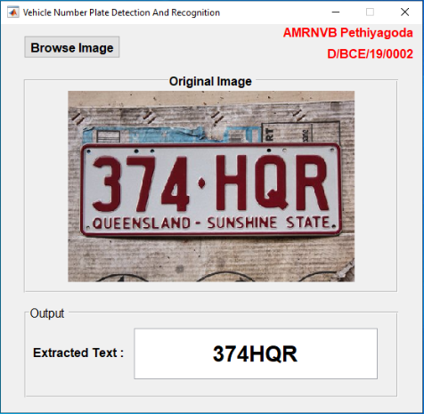**Output**

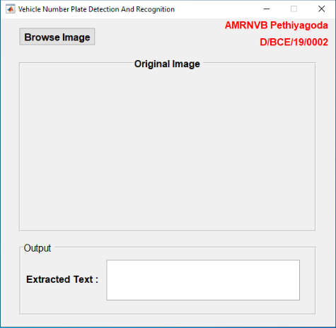

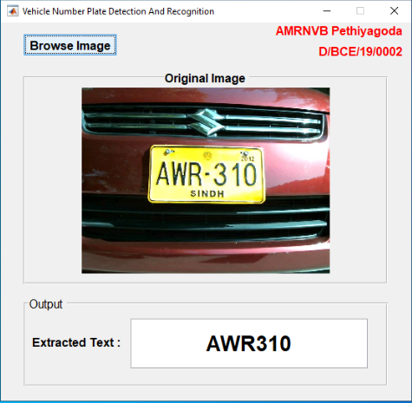

1. **System Architecture**

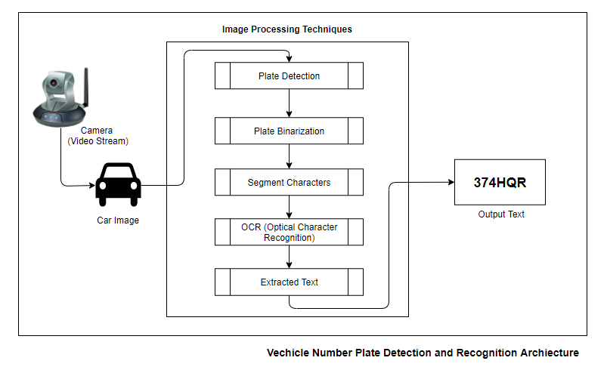

1. **Activity Diagram (Process flow chart)**

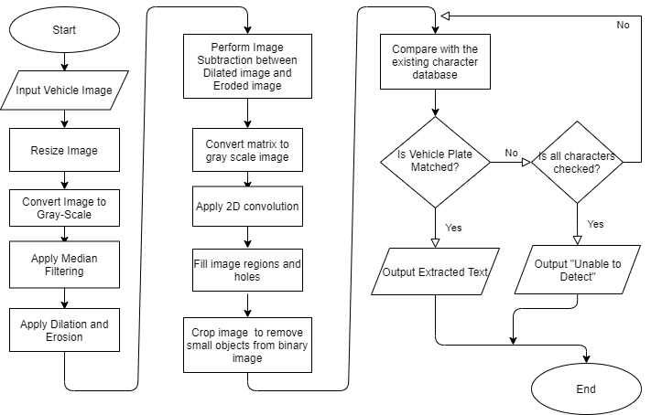

1. **Image Processing Techniques**

The vehicle image is given as an image, the image is then resized and converts the true color image RGB to the **grayscale image**. The rgb2gray function converts RGB images to grayscale by eliminating the hue and saturation information while retaining the luminance. Then performs **median** **filtering**, where each output pixel contains the median value in the **3x3 neighborhood** around the corresponding pixel in the input image.

A strel object is used to represent a flat **morphological** **structuring** **element**, which is an essential part of **morphological dilation and erosion operations**. Then **Image Dilation and Erosion** is applied.  The two obtained images are **subtracted** with each elesment in array ge from the corresponding element in array gi and returns the difference in the corresponding element of the output array gdiff. Then sets the values to the minimum and maximum values in gdiff.

The [**two-dimensional convolution**](https://in.mathworks.com/help/matlab/ref/conv2.html#bvgtfv6) of matrices is returned. The intensity values of image are adjusted. The image regions and holes are filled. The image is then **cropped** removing small objects from binary image.

Finally, the characters are cropped to obtain them individually and compare them with the generated alphanumeric characters to see if they match. The process continues until all characters are checked. If the suitable character is not found, then display a message that the number could not be identified. If all the characters are identified successfully then extract the individual characters concatenate them into a string and display it.